|  |
| --- |
| **Practical 9 OUTPUT****Use WEKA to implement Association Mining land clustering** |
| **K-means, Agglomerative and Divisive Clustering** |

**OUTPUT CUSTOMER CLUSTER KMEANS**

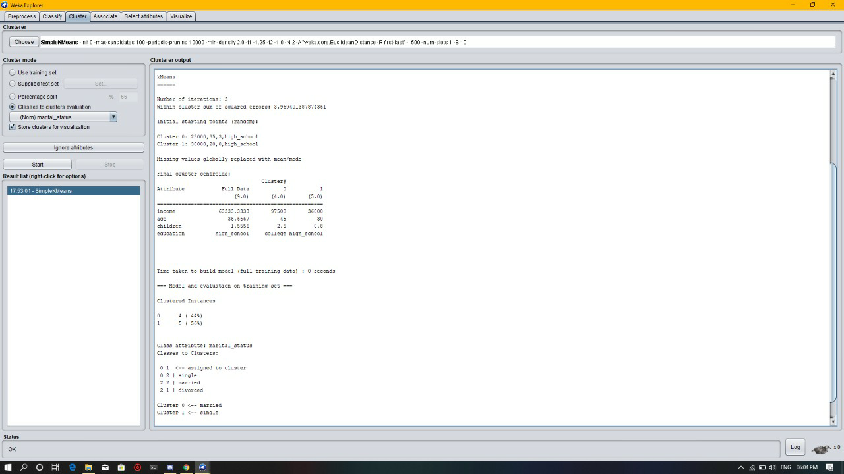

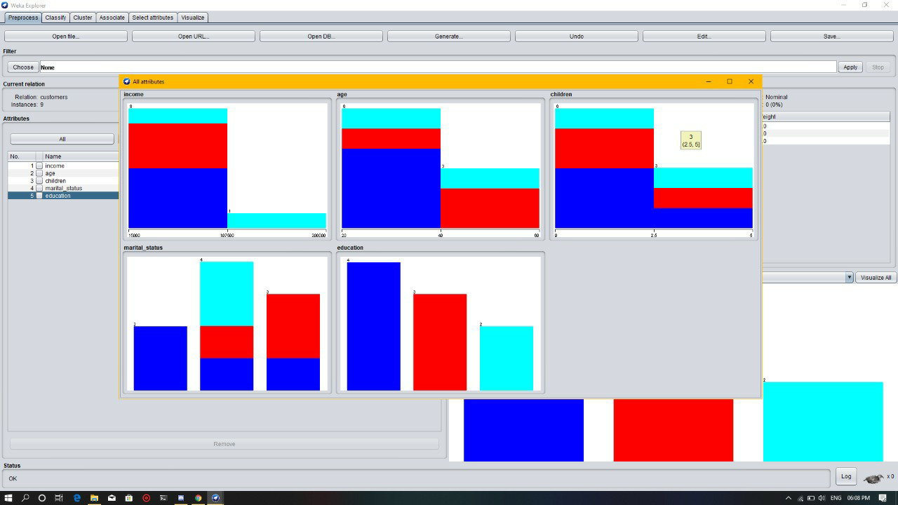

**OUTPUT ASSOCIATION GROCERY RESULT**

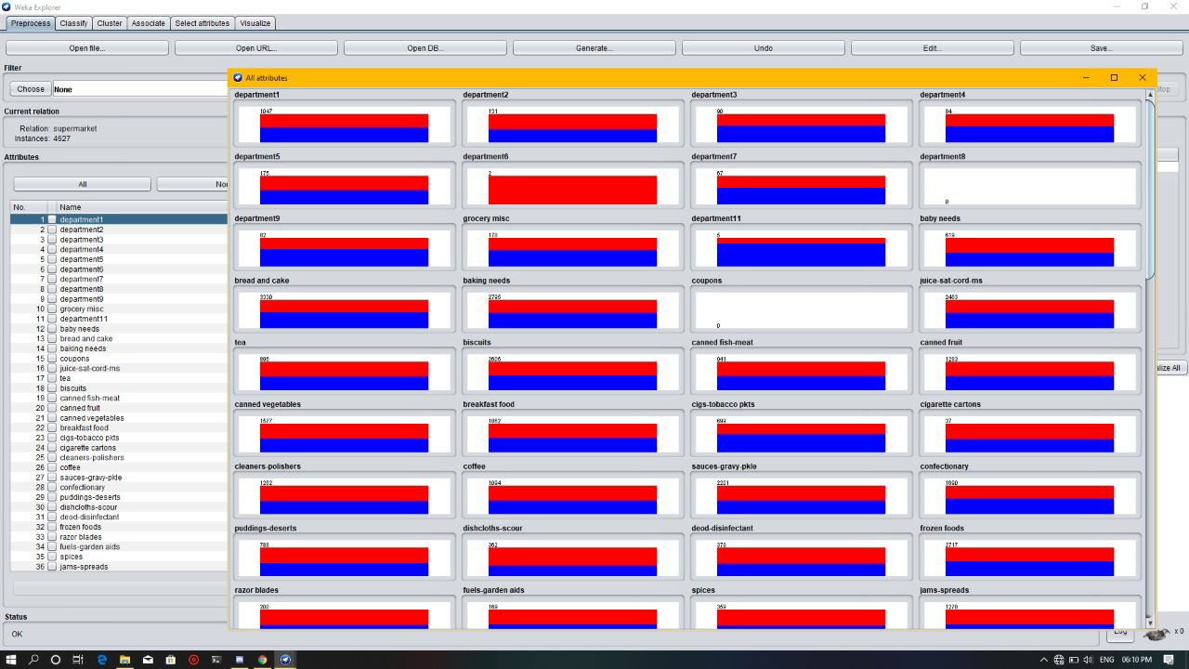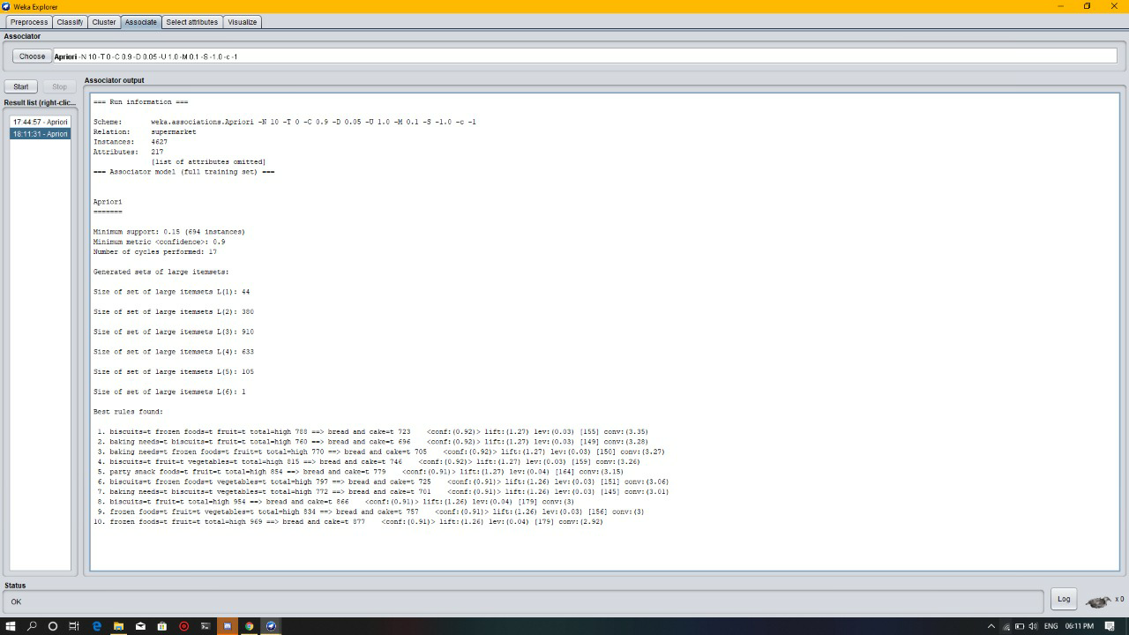

# C:\Users\alina\Downloads\IMG-20200327-WA0020.jpg